**UNIVERSITY OF CAPE COAST**

**SCHOOL OF PHYSICAL SCIENCE AND AGRICULTURAL SCIENCES**

**DEPARTMENT OF COMPUTER SCIENCE AND INFORMATION TECHNOLOGY**

Human Computer Interface, CSC 312

**Team 11**

Group project members:

1. PS / CSC / 15 / 0015
2. PS / CSC / 15 / 0026
3. PS / CSC / 15 / 0006
4. PS / CSC / 15 / 0032
5. PS / CSC / 15 / 0049

DATE: 31st March, 2018

**Task 3:**

TITLE

LOW FIDELITY PROTOTYPE(STORYBOARDS) FOR UNIVERSITY OF CAPE COAST WEBSITE.

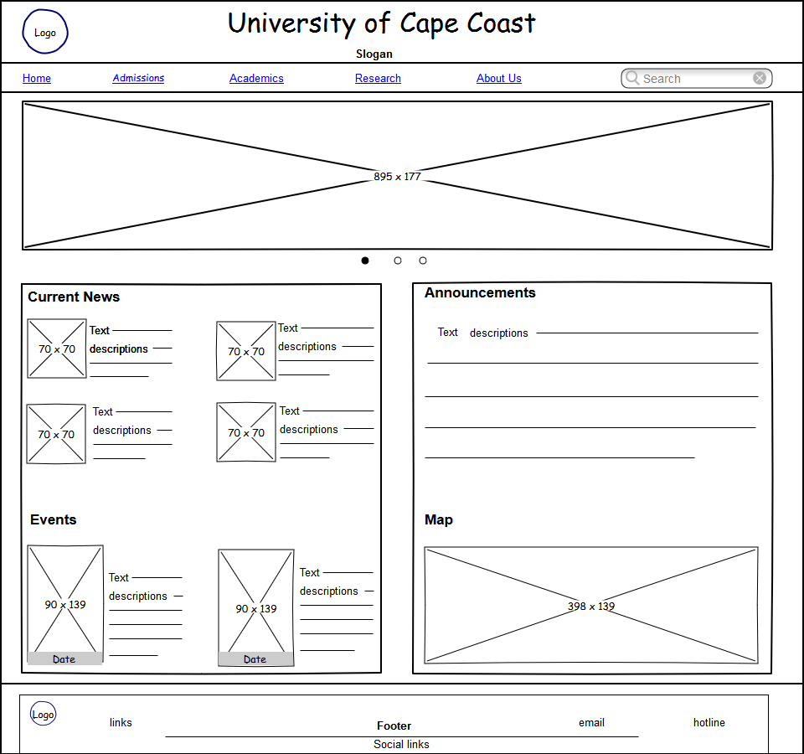

1. Homepage of Desktop version of the University of Cape Coast website.

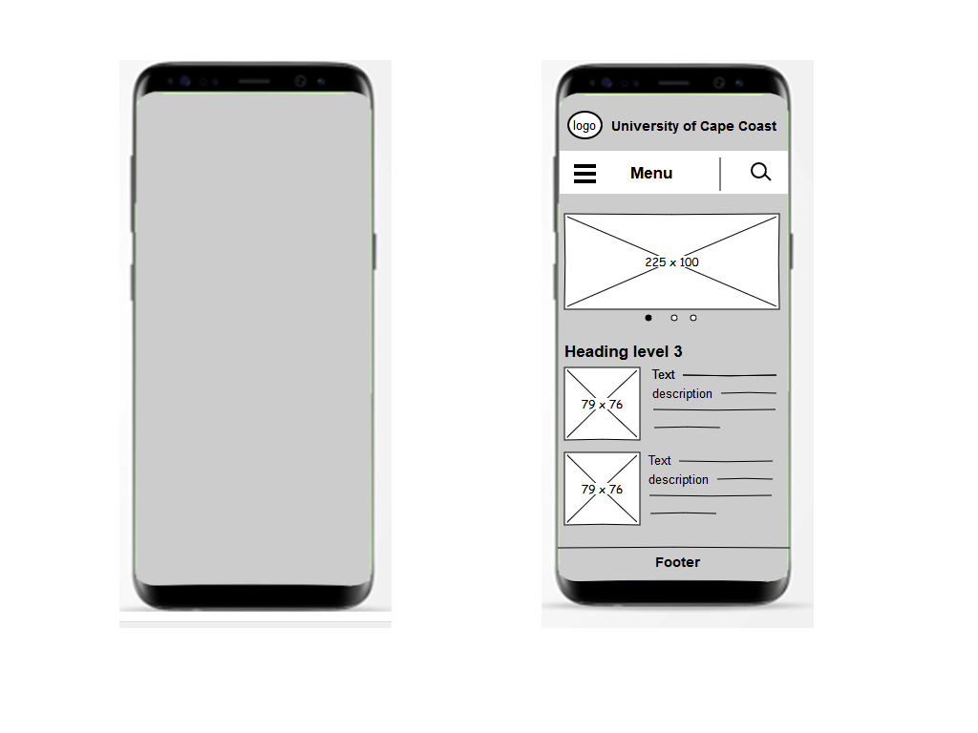

1. Display of Homepage of the University of Cape Coast website on Smartphone.

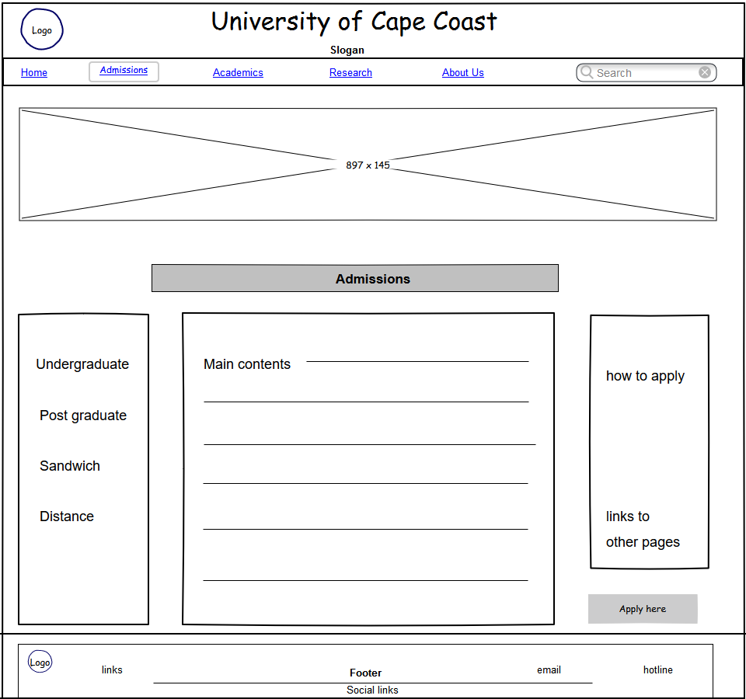

3. Display of Admissions page of University of Cape Coast website on Desktop.

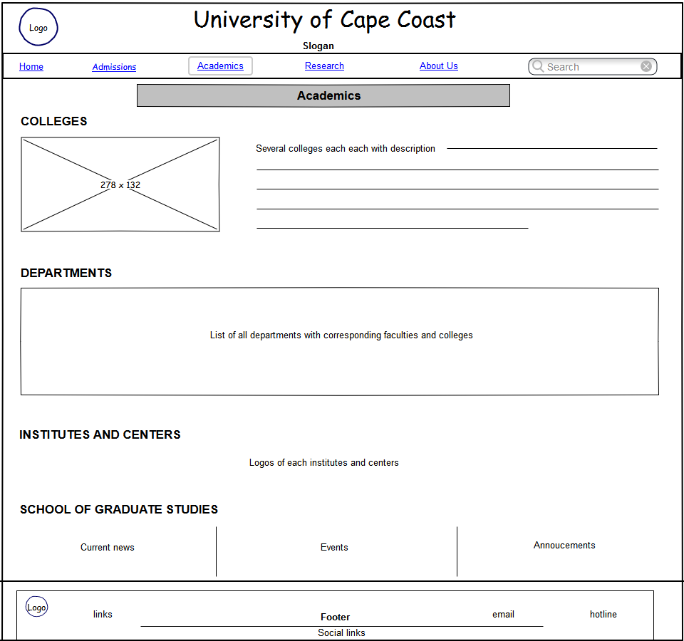

List of all departments with their corresponding logos, faculties and colleges and with links to their site

1. Display of Academic page of University of Cape Coast website on Desktop.

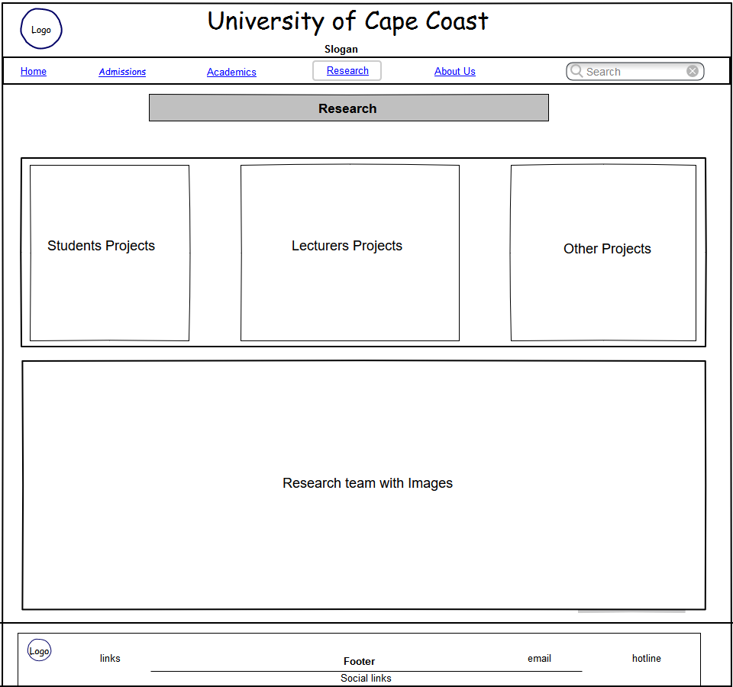

1. Display of Research page of University of Cape Coast website on Desktop

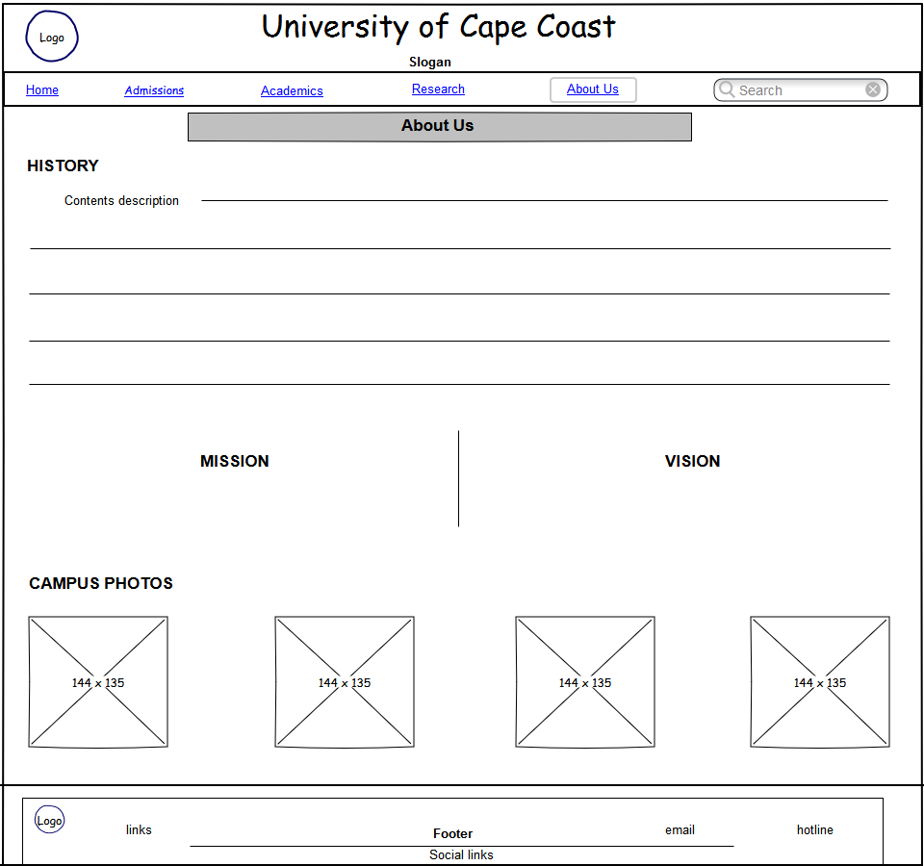

1. Display of About Us page of University of Cape Coast website on Desktop